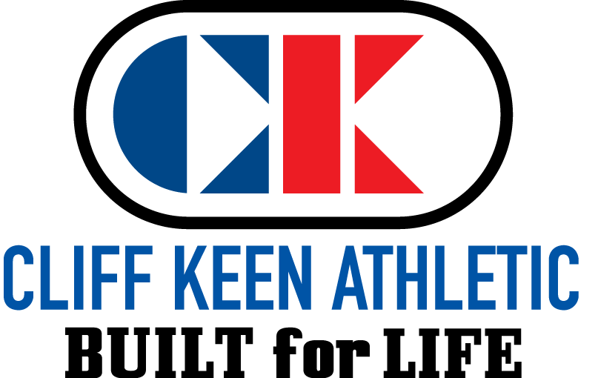
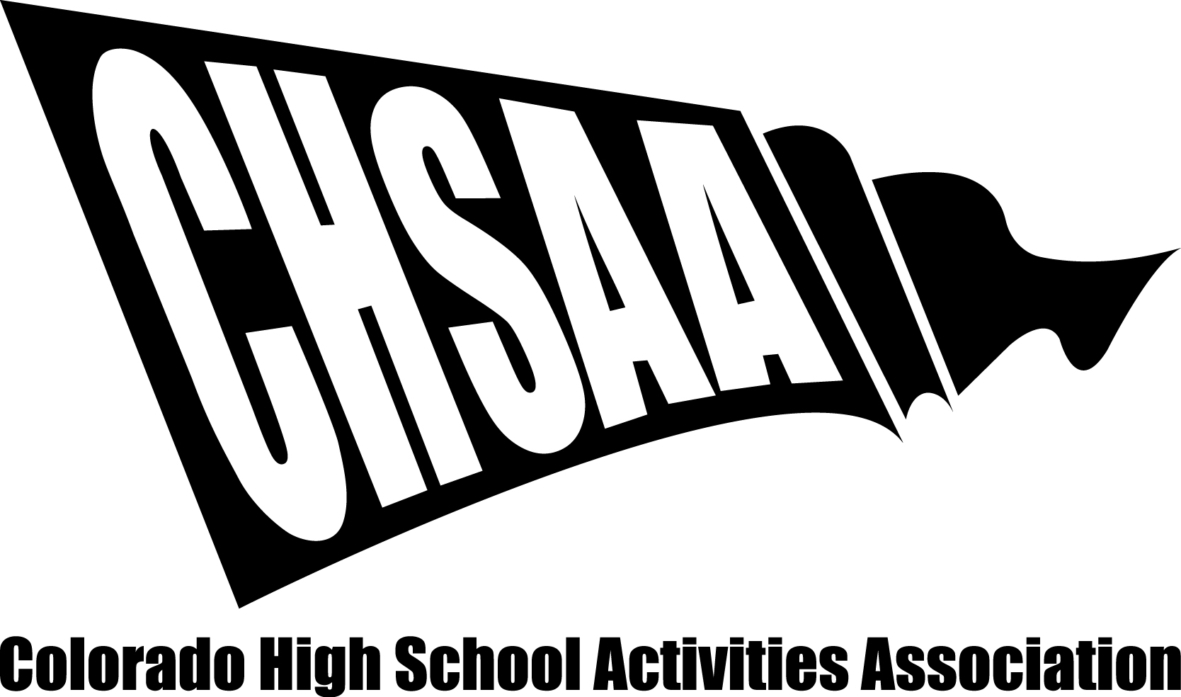
Cliff Keen Athletic National Alliance Program

Dear CHSAA Official,

Cliff Keen Athletic and the Colorado High School Activities Association (CHSAA) have recently come to an agreement that has allowed us to implement an incredible new program for your immediate use. On behalf of Cliff Keen Athletic, the largest manufacturer of the finest quality officiating products in the world, I am very happy to inform you that CHSAA has been selected as the newest member to be enrolled into the Cliff Keen Athletic National Alliance Program. Cliff Keen Athletic is now the exclusive, fully endorsed CHSAA supplier of officiating products for the state of Colorado.

This program was specifically designed for officials who work in select, integrity oriented conferences and associations across the country that want to wear and own the finest quality officiating gear available. You now will have exclusive access to all of your officiating gear and clothing directly from the Cliff Keen Athletic factory and from Authorized Cliff Keen Officials Dealers in Colorado, at special pricing. That being said, we want to personally welcome you as the newest member into the National Alliance Program, give you your account number and share with you a list of the free benefits that the National Alliance Program offers its new CHSAA members. The National Alliance Program is not open to the public, and based upon personal referrals and/or recommendations, enrollment is by invitation only.

Your National Alliance Account Number is: cohsas148
National Alliance Program Member Benefits:

- Special 25% Off Web pricing (the wholesale price) directly from Cliff Keen Athletic using your member account number set up specifically for each National Alliance Program affiliate member.

- Special discounts from Cliff Keen Authorized Officials Wear Dealers throughout the state of Colorado.

- Complete web access to the finest quality Cliff Keen Athletic products available on the market today, with special pricing, personal account log-in management, and inventory level checking capabilities.

- Preferred shipping, tracking and production for all Cliff Keen Athletic National Alliance Program member orders.

- Ability to customize a variety of products as well as having the ability to put letters, numbers, sponsors, insignias and conference or association logos on most all products. (must be within the rules/guidelines of the governing body)

To start using your member benefits, log onto www.cliffkeen.com and then click on “Log In” and register as a new account. Select the items you wish to purchase and continue to the final checkout page. In the final checkout area just enter in your CHSAA account number in the “Coupon Code” box to get your wholesale pricing. The web site will remember your account number and all your information. For further information, please contact Gary Peterson, the National Alliance Program Sales Representative at garypeterson@cliffkeen.com or call 435-231-4494, or Cliff Keen Athletic at info@cliffkeen.com or call 800-992-0799. Please note that the CHSAA discount is only available over the web.

All of us at Cliff Keen Athletic and the National Alliance Program wish you the best in all your officiating endeavors, and know that even though this avocation we have selected to participate in often goes unheralded, we enjoy what we do because of the commitment to succeed and the satisfaction we get by knowing we are prepared, fair and focused.

_________________________________________
National Alliance Program---Gary Peterson---garypeterson@cliffkeen.com 435-231-4494
Corporate Office---4480 Varsity Drive P.O. Box 1447 Ann Arbor, MI 48106
Phone: (734) 975-8800 Fax: (734) 975-9800 www.cliffkeen.com E-mail: info@cliffkeen.com

