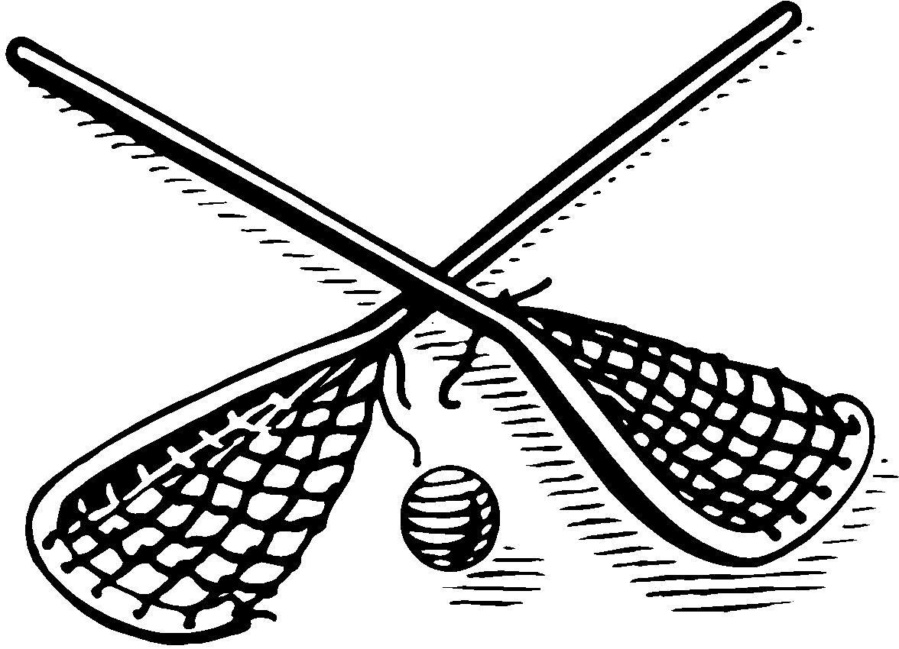 | CWLOA Registration: $25 _______  Shirt Payment: $18 _______  Total Paid _______  Cash / Check # _______  Make one check for registration fee & shirt payable to:  CWLOA

COLORADO WOMEN’S LACROSSE OFFICIALS ASSOCIATION

www.cwloa.com

2017 JUNIOR OFFICIALS REGISTRATION FORM

Junior officials are individuals still in high school and 18 & younger as of January 1, 2017

NAME: F M
ADDRESS: SCHOOL ATTENDING:
CITY/ZIPCODE: _ GRADE SPRING 2016: _
HOME PHONE: DATE OF BIRTH / /
CELL PHONE:
E-MAIL: PARENTS E-MAIL:
OTHER CONTACTS:
PLAYING EXPERIENCE: UMPIRE EXPERIENCE:
US LACROSSE NUMBER: RENEWAL DATE
You must have a current membership with US Lacrosse in order to officiate.
You must include your US Lacrosse membership information

ALL US LACROSSE REGISTRATIONS SHOULD BE SUBMITTED DIRECTLY TO US LACROSSE.
US LACROSSE REGISTRATION LINK: http://www.uslacrosse.org/membership.aspx
SHIRT SIZE ____________________________

CWLOA DUES Payable to CWLOA $25.00

Return this form and checks to:

Allison Bailey
CWLOA Treasurer
605 Walden Circle
Apt 102
Boulder, CO 80305

